Illinois
- Aptë gizhêk – Half Day, IL (half day or half of the sky) [named after a Potawatomi chief]
- Ėshkëm – Ashkum, IL (more & more) [named after Potawatomi chief Ashkum]
- Giwani – Kewanee, IL (prairie chicken)
- Kyankeké – Kankakee (low laying land) [Kickapoo]
- Mëkwan – Maquon, IL (spoon)
- Wakigen – Waukegan, IL (fort)
- Zhabné – Shabbona, IL (hard to kill) [named after Potawatomi chief Shabbona]
- Zhegagoynak – Chicago, IL (place of wild onions)

Indiana
- Abnabé – Aubbeenaubee, IN (h/s looks back) [named after Potawatomi chief Aubbeenaubee]
- Giwani – Kewanna, IN (prairie chicken) [named after Potawatomi chief Kee waw nay]
- Këwézi – Coesse, IN (old man)
- Mkopenak – Portage, IN (place of bear potato) [bear potato grows a lot in this area]
- Mshiwakwa – Mishawaka, IN (big stand of trees)
- Mzhéwé wdé – Elkhart, IN (elk heart)
- Népni – Nappanee, IN (plant that is flattened)
- Winmėk – Winamac, IN (catfish) [named after Potawatomi Chief Winamac]
- Zénba odan – South Bend, IN (ribbon town) [Potawatomi used to trade for ribbon in South Bend]
- Zhepshiwanëk – Shipshewana, IN (lion / cougar den)

Mzhigénak – Michigan (place that has been clear cut) [in the 1800s-1900s there was a lot of clear cutting happening in lower Michigan]
Mshigmé – Michigan (big body of water) [describing the great lakes]
Ktthegmik – at / in the Great Lake (at or in a big body of water)

Lower Michigan
- Bawating / Pawating - Niles, MI (place of the rapids) [describes the flow of senathwen zibé or the St. Joseph River which flows thru Niles. Before the dam was put up, the river was about 12ft lower than it is today & had a lot of rocks in it. Senathwen zibé – rocky flow river]
- Bidaské – Petoskey, MI (light shinning towards)
- Byankik – Hartford, MI (place we came to) [after the death of Leopold Pokagon in 1841, a split occurred to where 2/3rds of the Pokagon Band moved to Rush Lake, in Hartford, MI]
- Gzigmezé – Kalamazoo, MI (boiling) [describing the fog coming off of the river giving the appearance of boiling water]
- Ktthegmik – Chickaming TWP, MI (at the big water)
- Médewen – Mattawan, MI (confluence of 2 streams)
- Menistegwé – Manistee, MI (river with islands) [the Manistee River has islands in it]
- Nadwézibik – Athens, MI, Huron Band (rattlesnake river)
- Nagneshkëmbes – Hartford, MI / Rush Lake (bulrush lake) [after the death of Leopold Pokagon in 1841, a split occurred to where 2/3rds of the Pokagon Band moved to Rush Lake, in Hartford, MI]
- Ndowathoyėk – Dowagiac, MI (place of harvesting / gathering) [Ndowathoyek was the name of a village in Niles, & New Buffalo, MI led by chief Topinabee, later on the City of Dowagiac adopted the name]
- Pepéya – Paw Paw, MI (paw paw / here & there)
- Wasëtenak – Grand Rapids, MI (where it is far)
- Wasëtenak – Washtenaw, MI (where it is far)
- Zagitëk – Saugatuck, MI (place of the mouth of the river)
- Zhabwagnak – Cheboygan, MI (sound of a drum going thru)
Upper Michigan
- Bawating – Sault St. Marie, MI (place of the rapids) [this location is where the Potawatomi, Odawa, & Ojibwe split ways. The Ojibwe are keepers of the faith, Odawa are keepers of the trade, & Potawatomi are keepers of the fire]
- Ėshkenabé – Escanaba, MI (first look)
- Gedémi azhbêkkêgok – Porcupine Mountains, MI (porcupine mountains)
- Gété gteganêk – Watersmeet, MI (at the old garden)
- Gtegan wékmega – Garden Peninsula, MI (garden peninsula)
- Shpëmëk – Ishpeming, MI (up / in the sky)
- Wigwaszibik – Bark River, MI, Hannahville (birch bark river)

Wishkosnak – Wisconsin (place of the prairie grass) [wishkosen – prairie grass]
- Agëm – Algoma, WI (snowshoe)
- Azhgas – Oshkosh, WI (little bridge)
- Béshtëgo – Peshtigo, WI (striped wave)
- Bimbnewan – Pembine, WI (hair roach on crochet)
- Biwabkozibik – Iron River, WI (iron river)
- Ė nish tëgwéyak – Two Rivers, WI (2 rivers)
- Éspen – Ashippun, WI (racoon)
- Ėzh wabmenan – Ashwaubenon, WI (the way I see you)
- Gigosés – Kegonsa, WI (little fish)
- Gizes – Keesus, WI (sun)
- Giwani – Kewaunnee, WI (prairie chicken) [named after Potawatomi chief]
- Giwéskëm – Kewaskum, WI (turning back on his tracks to go home)
- Gnogméyak – Long, Lake, WI (long lake)
- Gnozhé – Kenosha, WI (northern pike)
- Idwégam – Wisconsin Rapids
- Kwikwiyak – Green Bay, WI (place of ending water corner or bay)
- Mëktthakoynak – Phlox, WI (place of the frogs) [Potawatomis don’t have a “f” found, so when they heard people say “Phlox”, they though they were saying “frogs”]
- Mëkwango – Mukwonago, WI (beaver den)
- Menwakwa – Minocqua, WI (good stand of trees)
- Métawgak – Crandon, WI (place of sand) [the big lake in Crandon is Lake Metonga]
- Migwen – Maquon, WI (feather)
- Mishkat – Mishicot, WI (hairy leg)
- Mthezibé – Bad River, WI (bad river)
- Mkedéwabkok – Black River Falls, WI (place of black metal)
- Mkodbénak – Potawatomi Park Sturgeon Bay, WI (place of bear head) [at the golf course in Potawatomi park there is a totem pole that was put up & at the top of the pole there is a bear, this is also the resting place of Potawatomi chief Simon Kahquados] (see below)
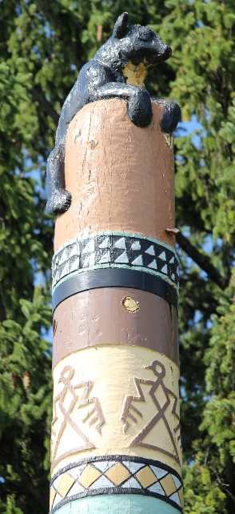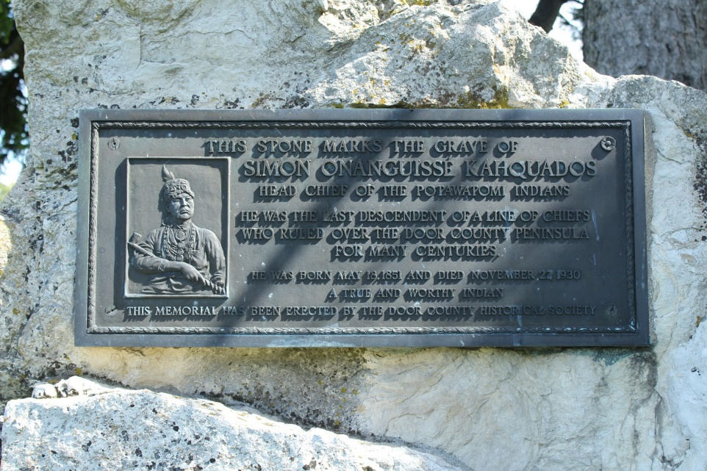
- Mnedoké – Mendota, WI (snake maker)
- Mnedowêk – Manitowoc, WI (place of spirits)
- Mnenak – Milwaukee, WI (taken by force)
- Mnomen – Manona, WI (wild rice)
- Mnomninak – Keshena, WI (place of the Menominees) [Keshena is the headquarters for the Menominee tribe]
- Mshimnë odan – Appleton, WI (apple town)
- Mskigwé – Muskego, WI (sunfish)
- Mskwedbénak – Red Banks, WI (place of the red head)
- Mthemnedombes – Devils Lake, WI (devils lake)
- Negosé – Nekoosa, WI (falling over)
- Nishodé – Nashota, WI (twins)
- Niyoni – Laona, WI [Potawatomis couldn’t pronounce “Laona” so it came out as Niyoni]
- Nsëwakwsék – Zoar, WI (place where 3 roads meet)
- Nsogmeyak / Nsogmak – Three Lakes, WI (place of 3 lakes)
- Nyéw o bet – Neopit, WI (one who sits 4th)
- Ogatthi – Okauchee, WI (something small)
- Pékwawé – Packwaukee, WI (it is shallow)
- Senakagmak – Stone Lake, WI (stone lake)
- Wabagok – White Rapids, WI area
- Waben – Waupen, WI (morning)
- Wabeno – Wabeno, WI (first light of day)
- Wabgé – Waupaca, WI (h/s looks on) [bald eagle clan name]
- Wakwshé – Waukesha, WI (fox)
- Wabeshka – Waubesa, WI (white foam)
- Wasë – Wausau, WI (far away)
- Wasëké – Wausaukee, WI (far away land)
- Waswagnak – Lac Du Flambeau, WI (place of the torch)
- Wawatési – Wauwatosa, WI (firefly)
- Wawika – Weyauwega, WI (every so often)
- Wawnewikwédok – Egg Harbor, WI (egg harbor)
- Wawyégmak – Eagle River, WI (river bend)
- Wgëma – Ogema, WI (chief)
- Zhonya mbes – Silver Lake, WI (silver lake)
- Zhabwagnak – Sheboygan, WI (sound of drum going thru) [when native people were being persecuted for holding ceremonies, the Potawatomi held them in places where they were unable to be found. In the Sheboygan area there was a cave where the Potawatomi hid out to hold the ceremonies. Sheboygan means sound of a drum coming thru a cave.]
- Zhawno – Shawano, WI (South wind)
- Zisbakwtokanêk – Sugar Camp, WI (sugar camp)

